Luna McBride

Udemy: Data Science A-Z

**Homework: Tableau #1**

**Opening**

This is a write-up for the first Tableau of the Data Science A-Z class found on Udemy. This one covers a data set used primarily through this section, P12-Churn-Modelling.xlsx. Tableau is relatively simple compared to the ETL, so the homework is less strenuous than previous ETL homework. This is simply visualizations, so I will try to give insight to the graphs on top of them.

**Credit Score**

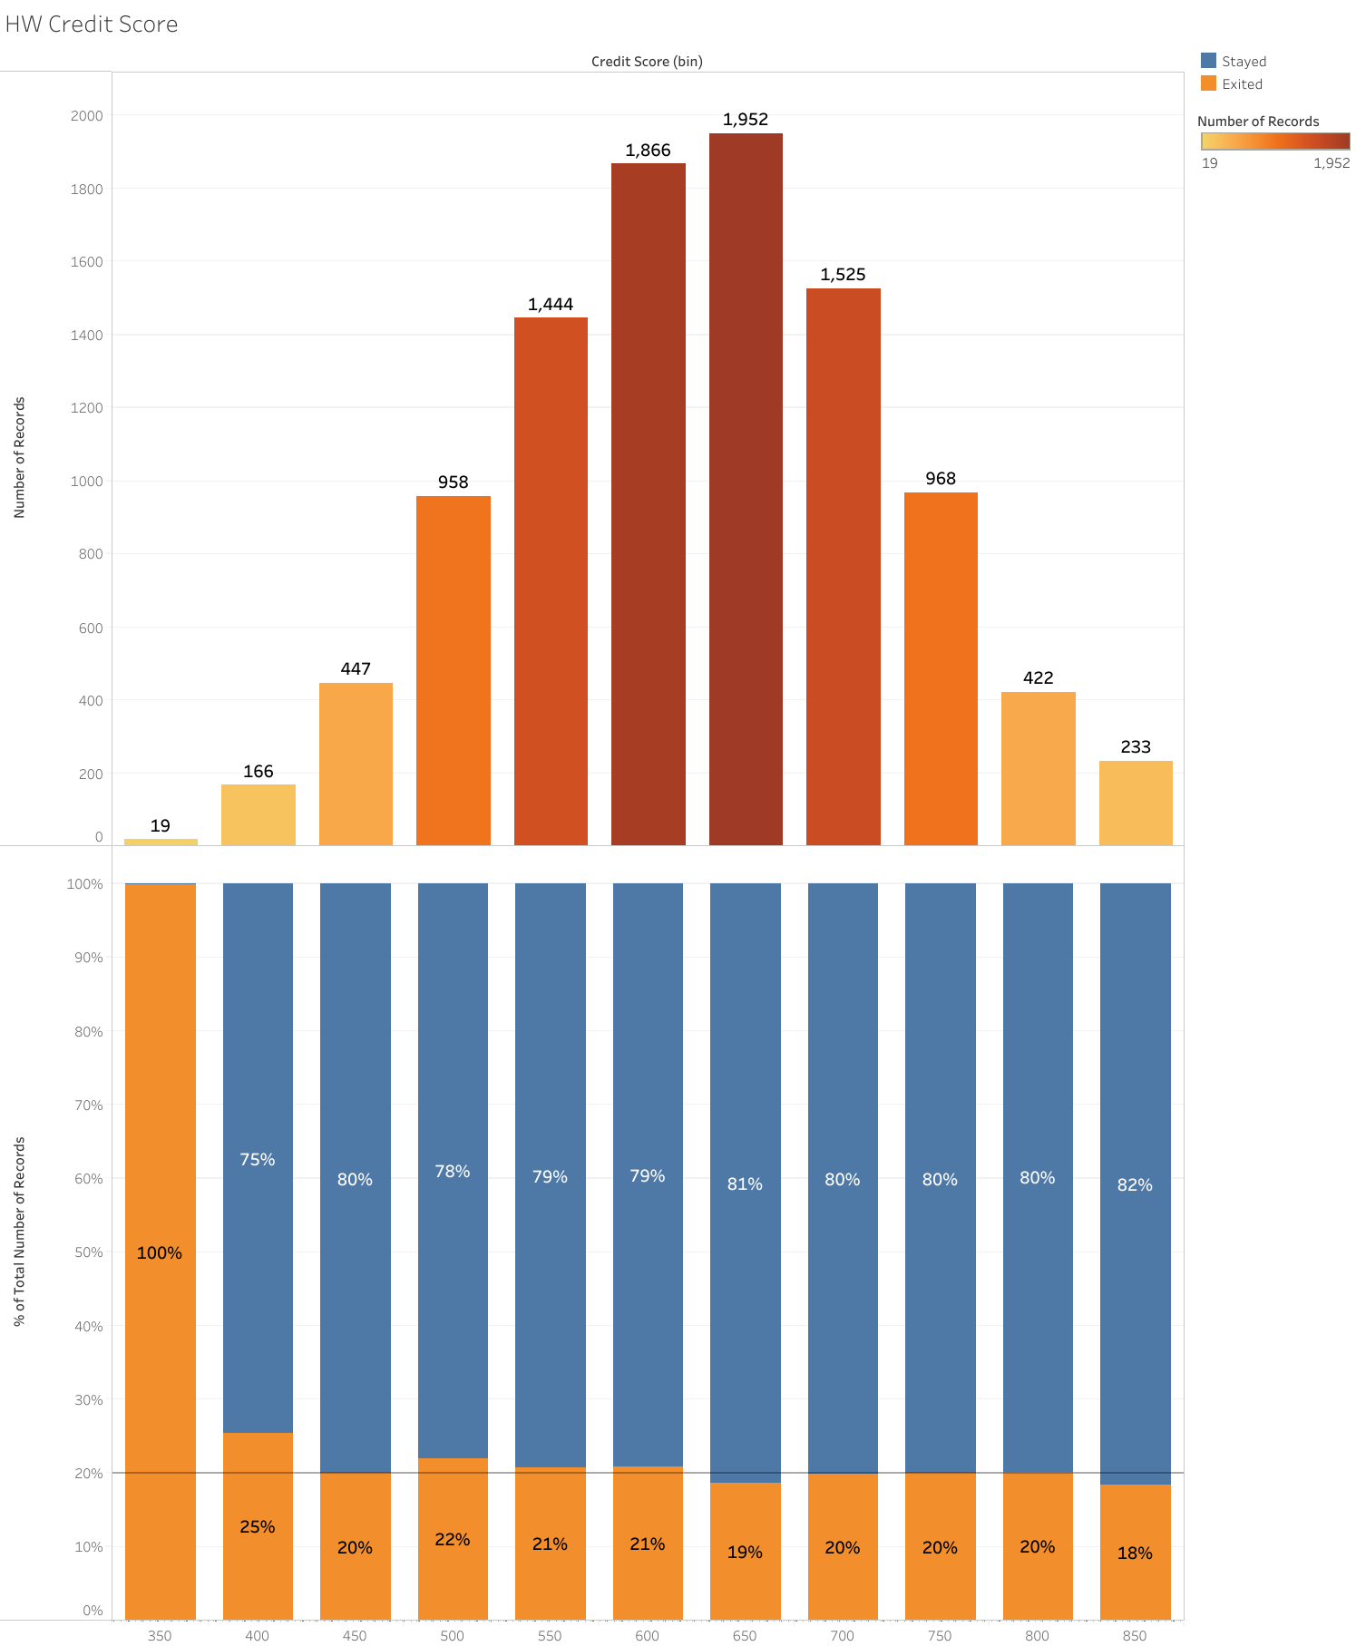

This information is formatted into two graphs. The top graph shows the number of individuals with that credit score put into bins of 50, listed at the bottom of the bottom graph since they are using the same segmentation factor. The second graph shows bars adding to a total of 100%, split by the number of people in that bracket who have left the bank (orange) and have not left the bank (blue). This graph also contains a reference line running across, which represents the average number of people who left the bank without looking at any one factor.

As for an analysis, the number of people in each bin follows a normal distribution, which makes logical sense for credit scores as a field of data. The majority of credit score brackets sit at just around average for exit rates, with the exception of the low credit scores. The lowest bracket, 350, had 19 members who all left. This would need to be looked into further, but due to the low number of individuals represented, this is likely just an anomaly in the data. Otherwise, the credit score would likely not be a significant factor in the rate of people leaving the bank.

**Tenure**

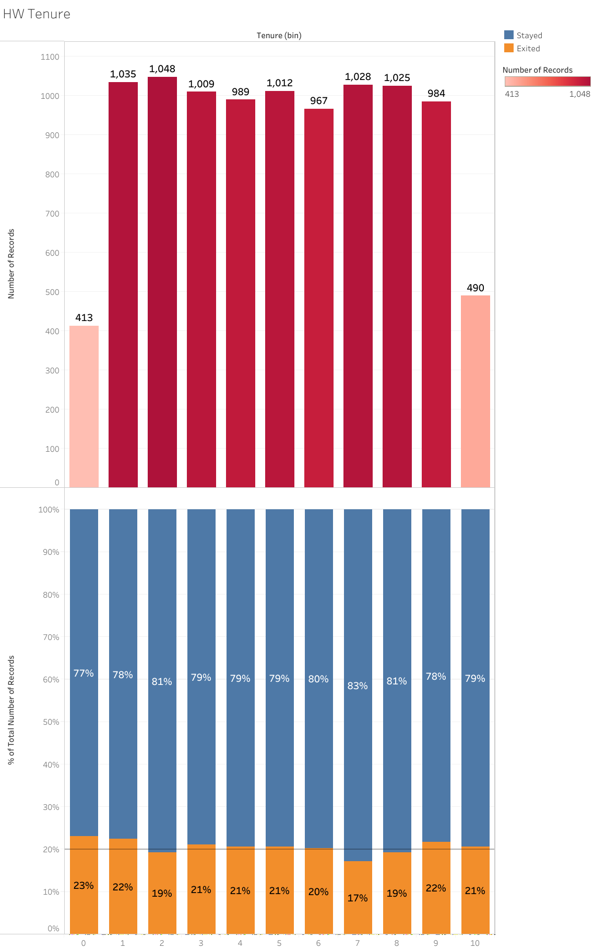

This one is structured similar to the first, with two graphs, one representing number within the bracket and the other representing exit rates listed as percentages. This set of bins represents tenure, or how long the person has been with the bank.

The first graph has the number of people in each year listed, which is surprisingly uniform for a bank. Perhaps this bank brings customers in in waves like recruiters do, but other than that it is quite odd that a bank has a more uniform number of people in each year of tenure. In addition, the exit rate is also uniform across everyone. This would be normal for other factors such as credit or age, but a bank should have people staying more the longer they have been with the bank. That is why loyalty programs exist. This may be something for the bank to look at, as having people just as likely to leave no matter how many years they have spent with a service, let alone a bank, could mean there is something wrong with how the bank treats its patrons. Of course this is a data set meant to represent a subset of bank patrons for a bank that does not actually exist, so this is not something that could be looked into, but it would be concerning in an actual bank setting and would definitely be something to be looked into in a real world scenario.

**Conclusion**

Tableau is a very powerful tool for visualizing data and building insights from said data. This has led to some really nice-looking tables that are quite easy to make and read with the right data. The data given is not for an actual bank, of course, but good insight could be brought just from seeing the data. Building on this skill could really be helpful to companies, so I look forward to finding out more.